Housebreaking Breakthroughs
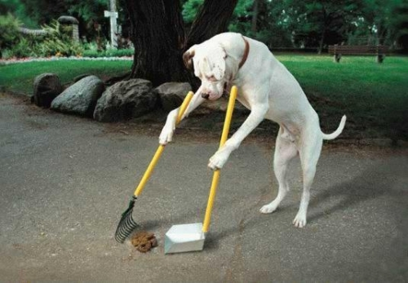
Successful housebreaking is, by far, the most important element of a loving, lifelong relationship between you and your dog.
If you don’t teach your new best friend not to pee and poop in your house, he won’t be your friend for long!
Fortunately, housebreaking a puppy (or adult dog) isn’t complicated. All you have to do is prevent peeing and pooping in the house, and reward peeing and pooping outside. While putting this simple concept into practice isn’t difficult, it does require your diligence, dedication, and patience. But the rewards are definitely worth the effort!
In this report, we’ll provide some general information about dogs on which our housebreaking techniques are based, explain the benefits of crate training, and then give you the step-by-step process for housebreaking your dog.

Five Facts
Here are five facts that will guide your housebreaking training:
Fact 1: Adult dogs can be housebroken the same as puppies.
If you adopt an adult dog, you may not have to worry about housebreaking if he has already been properly trained. Dogs—even the smartest ones—do not naturally know it’s wrong to go potty indoors. They must be trained, and most adult dogs are. But you can’t assume this is the case. If he was always kept outdoors, raised in a cage at a puppy mill, or improperly trained by a previous owner, you will need to start fresh and housebreak him using the same basic techniques as you would for a puppy. Adult dogs don’t have to go as often as puppies, though, which will make the training much easier for you. (On the other hand, adult accidents will create bigger messes!)
Fact 2: Puppies have limited bladder & bowel control.
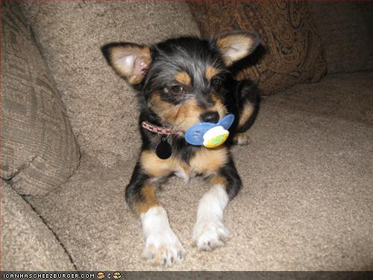
A puppy younger than 20 weeks old will need to go potty once every hour when awake. A very young puppy (under 12 weeks old) will need to go more often—every 30 minutes or even more frequently.
For an older puppy, a general rule for determining the number of hours he can go without going potty is to take his age in months and add one. So a four-month-old could hold it for about five hours. Small breeds can’t hold it as long; large breeds can hold it a bit longer. Remember, this is a general rule; your puppy’s control may vary.
When sleeping, puppies can wait longer. But don’t think a puppy who can hold it for 6 hours while sleeping can hold it that long while awake. He can’t.
Fact 3: Dogs like to sleep in a clean area.
If given a choice, dogs, like people, will never sleep in an area that is soiled with pee or poop. In the wild, “dogs” (wolves, coyotes, foxes, etc.) sleep in a den and go outside to relieve themselves. Their pups learn to do the same.
Because dogs will try their best not to soil their sleeping area, your puppy is less likely to pee or poop in a small “den.” Confining him to that “den” whenever you can’t watch him will guarantee he doesn’t get a chance to begin the bad habit of going anywhere else in your house.
Fact 4: Dogs do best when kept to a routine schedule.
Feeding your dog on a set schedule will help him to go potty on a regular schedule. If you let your dog eat and drink whenever he wants, you’ll be less able to predict when he’ll need to go out. Take him out on a regular schedule, too!
Fact 5: Punishing a dog after he has an accident in the house is pointless, and may do more harm than good.
Your dog will not understand that you are upset about something that happened in the past—even if it was just a minute or two ago. He will think he’s in trouble for what he’s doing at the instant you discover the mess and go ballistic… whether he’s happily coming up to greet you or sitting quietly. This, obviously, is the wrong message to give your dog.

Common Scents
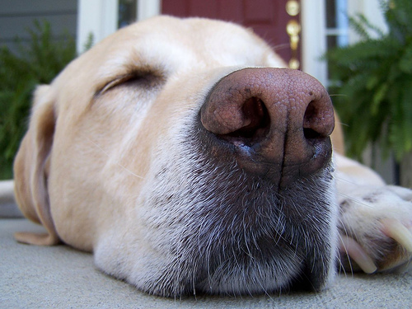
Photo Credit: http://www.flickr.com/photos/flattop341
A dog relies on his nose and scent to find “the bathroom.” If a dog has gone potty in your house before, this will leave behind a chemical scent that says “this is the potty place!” This scent will be hard for your dog to resist. That’s why you should make sure there is no odor of urine or feces in the house before beginning to housebreak a new dog or puppy.
Do not use a cleaning solution that contains vinegar or ammonia (the scent is too close to urine scent). You can use baking soda or club soda… or purchase special odor-eliminating cleaners at a pet supply store.
Equally important to cleaning up the scent of past mistakes is marking rooms with the scent of your happy “pack.” A dog will be reluctant to go potty where he and his pack (you and your family) live. That’s why an unhousebroken dog who can’t get outside will often run to a rarely used area of the house, such as a guest room, to go potty.
Once you have removed the scent of urine or feces, spend time in each room with your dog (especially the rooms you rarely use). Sit on the floor and play with your dog in each room for several minutes each day. Soon the room will be marked with a scent that says to your dog, “this is a no-potty zone!”
It will be difficult to mark every area of your house this way, and even if you could, this is more of a passive deterrent than a foolproof method to prevent your dog from going potty indoors; additional action is needed, especially for a puppy.
Crate Training and Housebreaking Go Hand-in-Paw
If your puppy is free to run all over the house, he’ll go potty whenever he gets the urge instead of learning to hold it. You can’t watch him closely enough all the time to prevent this. So set him up for success instead of failure.
Remember Fact 3: Dogs Like to Sleep in a Clean Area. By confining your puppy (or dog) to a “den,” you will inhibit him from peeing or pooping (teach him to hold it), since he won’t want to soil his sleeping area. You’ll also be able to accurately predict when he needs to go potty: immediately after being released from confinement.
We recommend you create a cozy den for your puppy out of a dog crate.
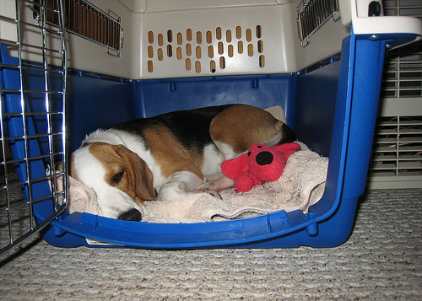
Photo Credit: http://www.flickr.com/photos/cogdog
Make sure the crate is big enough for your puppy or dog to be able to stand up, turn around, and lie on his side—but not so big that it gives him room to pee or poop in there without lying in it.
Line the crate with a towel you’ve used or a t-shirt you’ve worn (so your scent is on it). Make the crate comfortable for your puppy.
Place the crate in a quiet area, away from distractions (not too close to a window or in a high traffic area of your house), but not away from his “pack” (you and your family).
Some people choose to put the crate in their bedroom, but this may interrupt your sleep as the puppy will likely whine (and/or bark) the first few nights.
Before confining your puppy to his crate, you first need to teach him to enjoy being in it. Say “crate” and toss a few treats into the crate and see if he goes in to get them. Praise him if he goes inside. If he doesn’t go inside, put the treats on the lip/entrance of the crate, instead.
Gradually move treats farther into the crate until he goes all the way inside to get them. Do not close the door; let him go in and out as he pleases.
Make it a fun game by tossing treats into the crate a few times in a row, off and on throughout the day. Say “crate” whenever you want him to go in, and praise him when he does.
After he appears comfortable with the crate and eagerly runs in to get the treats, shut the door for a second after he goes in… then open it and let him out. Do that a few times. Then try shutting the door and leaving it shut as you feed him a few treats through the door. Then let him out.
The next step is to stuff a hollow chew toy (such as a Kong®) with something delicious. Let your puppy sniff the stuffed chew toy and then place it in the crate. Shut the door with your puppy on the outside. Usually it takes just a few seconds for your puppy to beg you to open the door and let him inside. Say “crate,” let him into the crate, praise him for going inside, and shut the door. Once he’s busy licking the treat out of the chew toy, walk away. Return before he finishes licking all the goodies out of the toy, and open the door. Don’t let him take the chew toy out of the crate; take it from him.
Next, tie the freshly stuffed chew toy to the inside of the crate and leave the door open. Your puppy can then choose whether he wants to remain outside or go into his crate and start licking the treat from his chew toy. Most puppies choose to rest happily inside the crate and work on the stuffed chew toy. He may even fall asleep in there when he’s done. Close the door.
Speaking of sleeping, you’ll also want to put your puppy in the crate when he’s sleepy. Encourage him to get into his crate with treats and by saying “crate” when you notice he’s about to fall asleep. Close the door after he goes in. If you find him already asleep, pick him up and put him inside, as gently as you can. Close the door.
With several instances of this pre-conditioning, some puppies will quickly accept being confined in their crate at night; others will whine or bark like mad to be let out. Sometimes putting a cover over the crate will help your puppy to settle down and go to sleep.
Ignore a puppy’s immediate whining and barking to be let out, otherwise you’ll teach him that whining and barking is the key to getting what he wants (very bad idea). Most puppies will settle down after a few minutes and go to sleep.
If he starts whining after being quiet for a while, he may need to go potty. You should take him outside, but don’t let him out of the crate as he’s whining. Wait a moment to see if his whining pauses, and then quickly open the door and take him outside. If he doesn’t pause on his own, make some sort of noise that will cause him to stop whining and listen. Then get him out right away before he starts whining again.
Use the crate at night and during the day whenever you’re unable to watch your puppy or have him outside.
Do not use the crate as “punishment.” If you scold your puppy and then lock him in the crate, he’ll associate the crate with being punished. You want him to think of his crate as his comfortable den—not a jail cell.
Follow these steps, and after just a few days your puppy will consider the crate to be his safe, cozy den and will happily rest inside.
It’s All in the Timing
Successful housebreaking is all about timing. Your goal is to have your puppy in the right place (outside) at the right time (when he needs to go); and avoid having him in the wrong place (inside) at the wrong time (when he needs to go).
This will be much easier when you’re able to predict when your puppy needs to go. Keep Fact 2: Puppies Have Limited Bladder & Bowel Control, in mind.
Usually, puppies need to pee right after waking up from a nap, and poop within a couple of minutes of that. If you don’t want to wait around for your puppy to wake up and do his business, you can wake him up when you are ready and the time is right.
Another critical element of timing is that you immediately reward your puppy for doing the right thing (we covered this in our Pre-Training Basics report). When your puppy goes potty when and where you want, your immediate and lavish rewards (praise and yummy treats) will teach him to repeat this correct behavior.
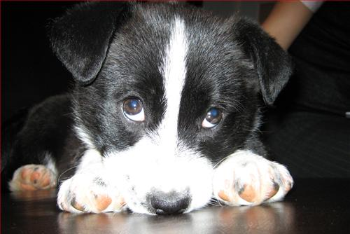
Step-By-Step Housebreaking Process
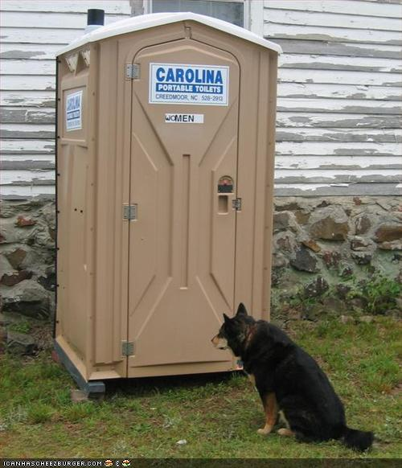
A new puppy (or dog) that is not housebroken should be restricted to one of these three situations at all times:
1. Inside under your constant and attentive supervision.
2. Outside with you.
3. Confined to his crate/den.
Situation 3 is where your puppy should spend most of his time during the housebreaking process.
Did you notice that we did NOT include a situation where you leave your dog outside all the time? Many people mistakenly think that puppies kept outside will be less trouble—after all, they won’t be peeing and pooping in your house, and they won’t need your constant supervision, right? But here is the reality: puppies left outdoors and unsupervised for long periods of time seldom become housebroken. They tend to bark, chew, dig, and escape from your yard. Outdoor puppies also become so excited on the rare occasions when they are allowed indoors (excited puppies tend to pee without warning), that eventually they are no longer allowed inside at all. We don’t want that. You shouldn’t want that.
Here’s how to housebreak your four-legged friend:
1. Determine where you want your dog to go potty. It’s best to pick a doggy toilet area that’s relatively close to the door, so you and your dog don’t have too far to go when he’s gotta go. Give the location some thought, because after he’s trained, your dog will continue to use this place as his toilet. This is convenient for clean-up time, especially if you have a large yard—and your family won’t have to be wary of little “landmines” when playing outside in the non-doggy-toilet areas.
2. Know when your puppy needs to go. Until your puppy is trained to tell you when he needs to go outside (don’t worry, that will eventually happen), you have to be an expert at deducing this. Sometimes a puppy will need to go within 5 minutes of going! Don’t assume you don’t have to watch him just because he’s just gone potty.
Here’s when you should take a puppy out to go:
- Immediately after he wakes up.
- Immediately after letting him out of his crate/den.
- Every 30 to 60 minutes while he’s awake, based on his age (see Fact 2).
- After he eats or drinks.
- When he’s been doing something for a while (like chewing on a toy), and then gets up and starts looking around.
- When he starts sniffing the floor.
- When he goes to an area where he’s gone potty before.
- When he’s running around and excited more than usual.
- When he’s look at or wandering near the door.
- When he’s pacing, whining, or starts to squat (duh!). Note: Male puppies squat to pee just like female puppies (versus lifting a leg) until they are 4-9 months old.
3. Keep your puppy under your constant and attentive supervision, or confined to his crate, when indoors. It only takes a couple of seconds for a puppy to squat and pee, so you must watch him very closely. Don’t stare at him (it’ll make him nervous), but keep an eye on him at all times when he’s out of his crate. This will be easier if you limit his movements, either by keeping him on a leash or by restricting him to one or two rooms.
Don’t think you can watch TV, wash the dishes, or do something else and still watch your puppy. If you become distracted or preoccupied, accidents will happen and this will make housebreaking your puppy a longer, more difficult task. It’s your responsibility to take him outside when he needs to go. Accidents will be your fault, not your dog’s.
4. Take your dog to his designated toilet area every hour or whenever he needs to go (see Step 2), whichever is less, and teach him to go on command.
- Every hour, fill your pocket with treats, release your pup from his crate and quickly take him outside to the designated toilet area. Encourage him to go quickly by enthusiastically calling “Outside, outside, outside!” (If you take your time, he may pee or poop en route. Also, hurrying him along tends to jiggle his bowels and bladder so that he really wants to go the moment you let him stand still and sniff his toilet area.)
Take your dog out every hour even if he’s old enough to hold it for longer than that. This practice is as much to train your dog—in the shortest time possible—to use the designated toilet area and go on command as it is for getting him outside in time to pee or poop!
- Use a leash (even if you have a fenced yard) to lead him to the correct place. This will also get him used to going potty while on the leash.
- Stand quietly (don’t stare at him) and wait until he begins to go. (If he stares at you instead of doing his business because he smells treats in your pocket, just look away and pretend to ignore him; eventually he’ll start sniffing and preparing to go.) When he does start to go, quietly (so you don’t startle him) say “go potty.” (You can choose another cue. Make it something you wouldn’t mind saying in public. Once you decide, be sure that you and your family use only this word/phrase, and use it every time he goes.)
- After your dog is finished, immediately give him a generous amount of tasty treats and lots of enthusiastic praise. Lavish rewards mean quicker results!
These steps are essential. If you just open the door and let your dog run out by himself to go potty, then give him a treat when he comes back to the house, his housebreaking will take longer and be less successful. Your dog will think he’s getting the reward for coming back to the house (versus going potty), and you’ll miss the opportunity to train him to go on command.
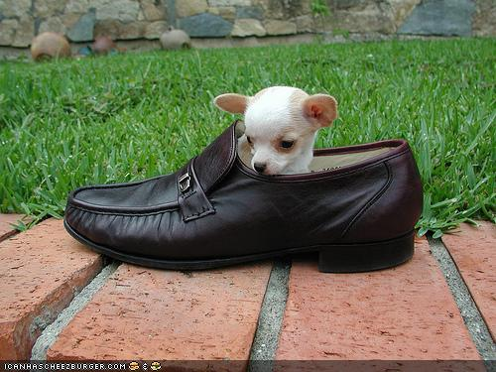
5. Spend time playing with or training your puppy, or take him for a nice walk (if he’s old enough). If you take him outside to go, and then quickly bring him back in and ignore him after he does so, he’ll learn that "after I go, my fun ends!" Consequently, he may become reluctant to go potty when he’s outside (and end up going inside when he can no longer hold it).
It is much better to praise your puppy for going potty and then take him for a walk as an extra reward for a “job well done.” This extra reward will also encourage him to go potty more quickly.
What if he doesn't go potty when you take him outside?
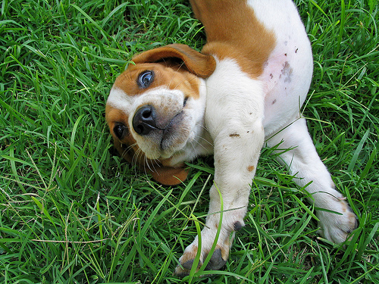
Photo Credit: http://www.flickr.com/photos/79286287@N00
If your puppy enjoys the great outdoors but doesn’t go potty within a few minutes, take him back inside, put him in his crate, and try again in 10 minutes or so. Repeat the process until he does go. Your puppy will learn that if he doesn’t go potty when you take him outside to do so, he’ll be confined to his crate again (no go, no freedom). Eventually he will go in the appropriate place at the appropriate time, and you will be able to give him appropriate rewards!
What about putting down newspapers?
Allowing a puppy to go potty on newspapers or some other kind of potty pad/material is a mistake. He will earn that he can go potty indoors, whenever he wants, as long as it’s on the paper. He will never learn to hold it; he may never be truly housebroken.
Control what goes in so you can predict when it will come out.
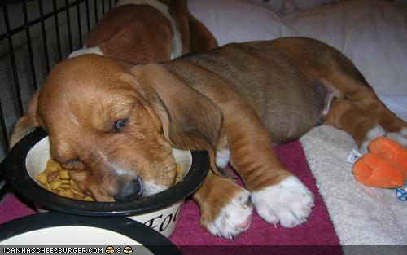
What goes into a puppy will come out with predictable timing (depending on the age and size of your dog). Feeding your dog on a set schedule will help him to go potty on a regular schedule. Generally, a puppy will need to go potty about 15 minutes after eating or drinking. If you let your dog eat and drink whenever he wants, you’ll be less able to predict when he’ll need to go out.
Feed your puppy at the same time each day. Leave the food there for ten minutes or so, then pick it up and put it away if he hasn’t finished it. A puppy younger than three months should be fed three times a day; older puppies and dogs should be fed twice a day.
Do not leave water out all day and night; put it down at regular intervals and pay attention to how much he drinks. Don’t let him drink water after 7 p.m.
Feeding dry food is better than canned food which contains more liquid.
Handling Inevitable Accidents
If you follow the steps in this report, you’ll have fewer accidents—but they will happen. Expect them. Don’t get upset at your dog when an accident happens. Instead, try to determine why it happened. Did you get distracted when you should’ve been watching him? Did you forget to take him out at the right time? Figure out what you did wrong, so it doesn’t happen again.
Despite what many people believe, dogs do not intentionally pee or poop in your house because they are angry, lonely, or want to “get back at you” for something. Dogs don’t think of pee or poop as something “nasty” to be used out of spite. And the so-called look of “guilt” or cowering in “shame” when you scold him is actually your dog’s way of showing appeasement and submitting to your obvious anger.
If you do not actually catch your puppy in the act, do nothing (except clean it up).
Do not—repeat—do not rub his nose in it, hit him, yell at him, shake him, or punish him in any way. Dogs don’t think about time the way humans do. Your dog will not understand that you are upset about something that happened in the past—even if it was just a minute or two ago. He will think he’s in trouble for whatever he’s doing at the instant you discover the mess and go ballistic… whether he’s happily coming up to greet you or sitting quietly.
What if you do catch him in the act?
If you catch your dog squatting and about to go potty inside the house, make a sudden, surprising sound—such as slapping the wall—not to scare him, but to get his attention so that he momentarily stops what he’s doing. Then urgently encourage your puppy to run outside with you. “Outside, outside, outside!” And finally, reward your puppy lavishly for going potty in the right place.
In any case, be sure to clean up all accidents quickly and thoroughly. You must eliminate any lingering scent so it doesn’t invite your puppy back for a repeat performance.
How Long Before He’s Housebroken?
When can you safely start leaving your puppy or dog alone in the house for a while? It depends on many things, including his age, size and—most importantly—your diligence in training him!
In general, if you follow these housebreaking guidelines, your dog should be making good progress within two months.
But some dogs learn quickly while others take more time. Gradually increase the amount of time you allow your puppy to be indoors, out of the crate, and monitor his progress.
Adult dogs generally need to go out at least once every four hours—first thing in the morning, around midday, late in the afternoon, and before going to sleep for the night.
If you can’t get be home to let your puppy or dog out often enough, consider hiring a pet sitter.
Expect accidents and set backs; they’re normal. Continue following the above steps and be patient.
Be Alert for Special Circumstances
There are a few reasons why it might be particularly difficult to housebreak a dog.
Dogs who were raised in puppy mills or pet stores, or who were regularly confined without the opportunity to go potty away from their sleeping area, will take longer to housebreak and require more patience and understanding from you.
Sudden changes in dog food brands or overindulgence in treats or table scraps can cause diarrhea.
There may be physical reasons, such as a urinary infection. Be sure to get your dog checked thoroughly by your vet.
In Summary
If you’re housebreaking a puppy, remember he doesn’t know anything yet. If you’re housebreaking an adult dog, there may be some old habits he has to “unlearn” first. Be patient, be consistent, be encouraging. A few weeks of dedicated effort on your part will result in a lifetime of clean floors and a beautiful relationship with your dog!
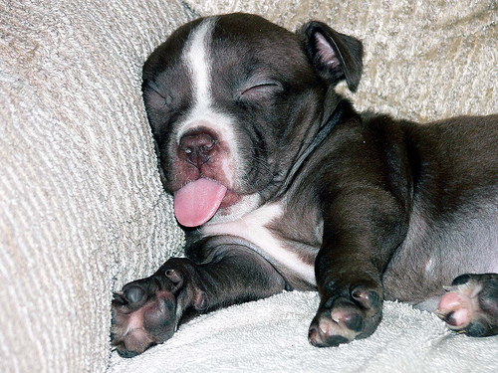
Photo Credit: http://www.flickr.com/photos/basykes/

